**ONLINE PLANT NURSERY**

A online plant nursery website to order plants via internet.

Front end project consists of Html,CSS,javascript and bootstrap.

This project comprises of Home page,Contact page,About us Page,Deal page,Login Page,Sign-in Page,Password recover pages with sub pages like Plants,Seeds,Bulbs,Planters and Soil&fertilizer.The project also consists of bonsai,Indoor plants,gift plants and Office plants.

HOME PAGE::

1)Header and Carousel

Header is created using html ,css and bootstrap.Icons and carousel effects have been implemented.sign in icon redirects to sign in page.plants redirect to plants page.The respective pages redirects to corresponding pages respectively,Except the Deal page.

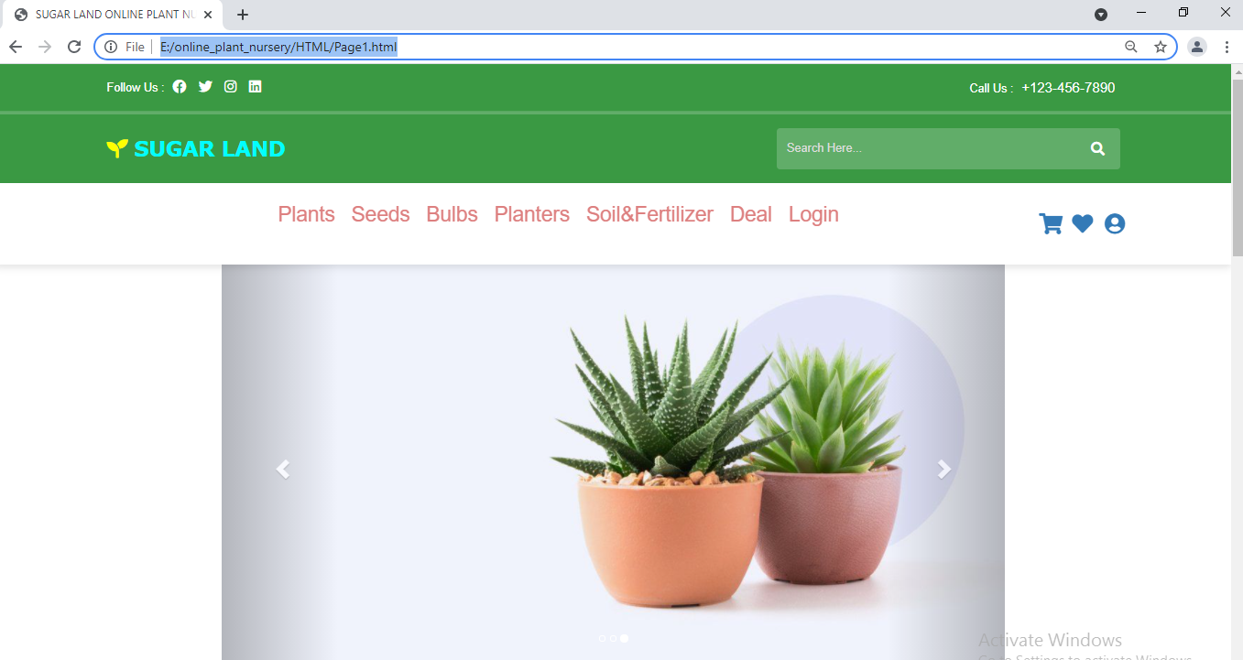

2)Category and Latest product

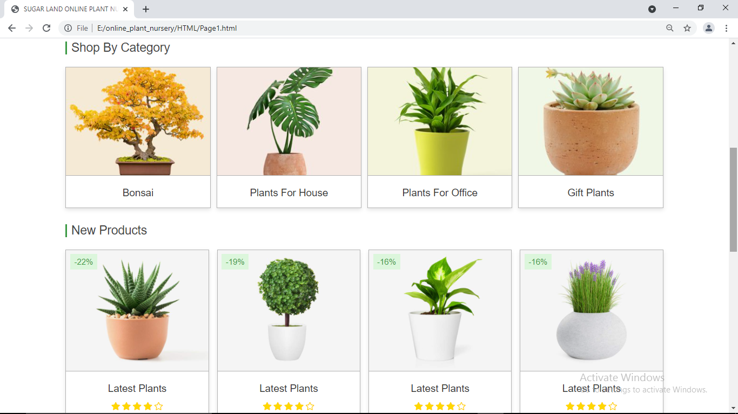

Options in shop by category leads to respective pages by clicking the shop now button.By clicing the add to cart option in new products directly you can add the plants to cart.

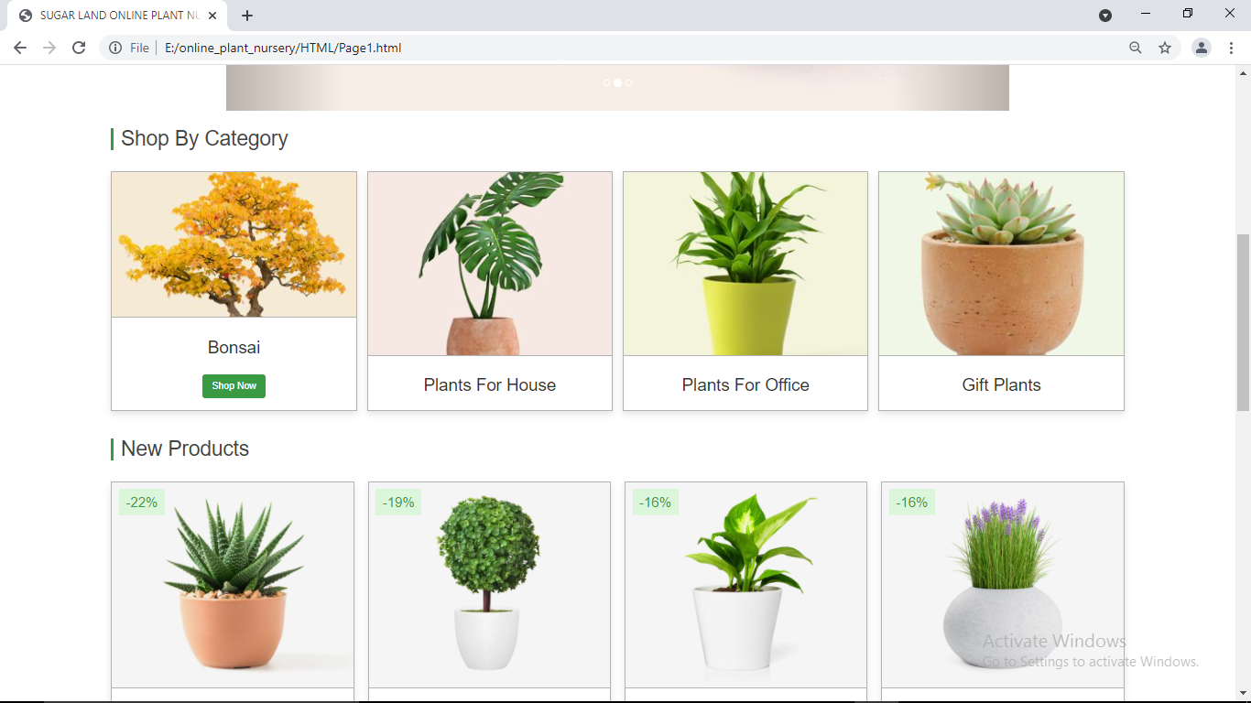

BootStrap navigation bar is used.

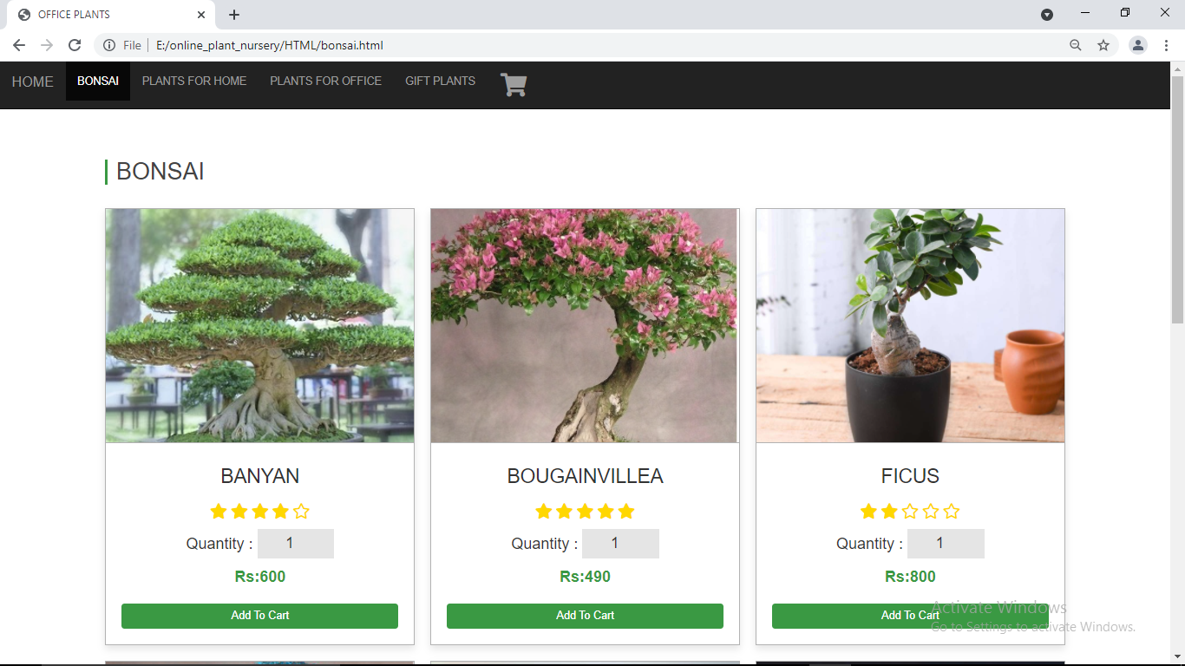

3)Footer

The about us page contact us pages are redirected from here.The icons redirects to facebook,instagram,twitter …..pages respectively

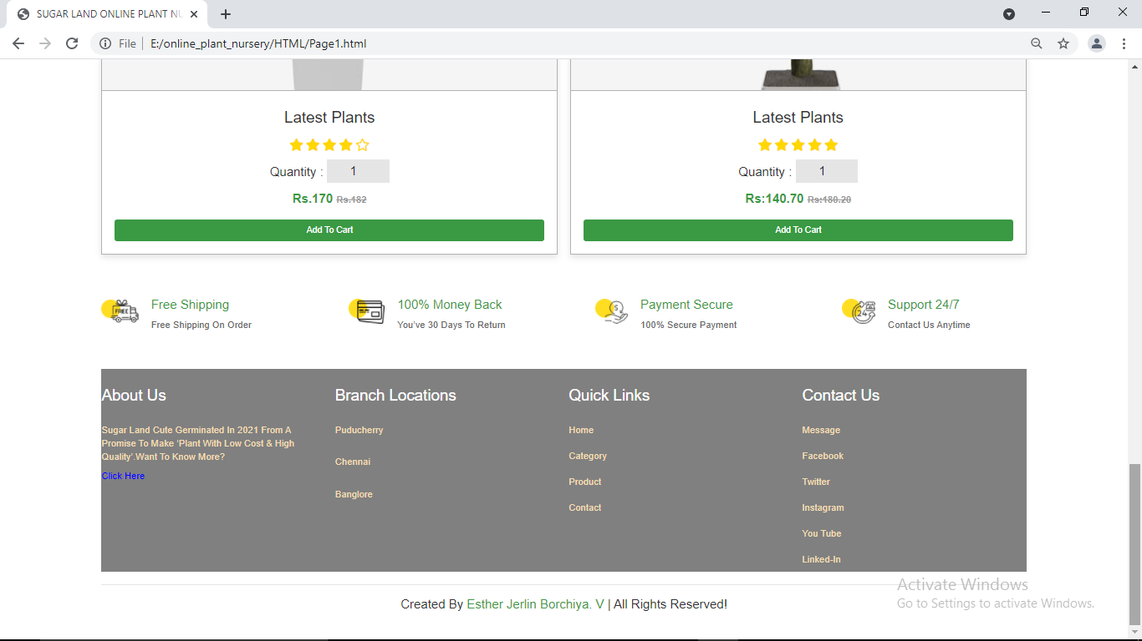

CONTACT PAGE:

The google map feature has been used to identify the location of the nursery.

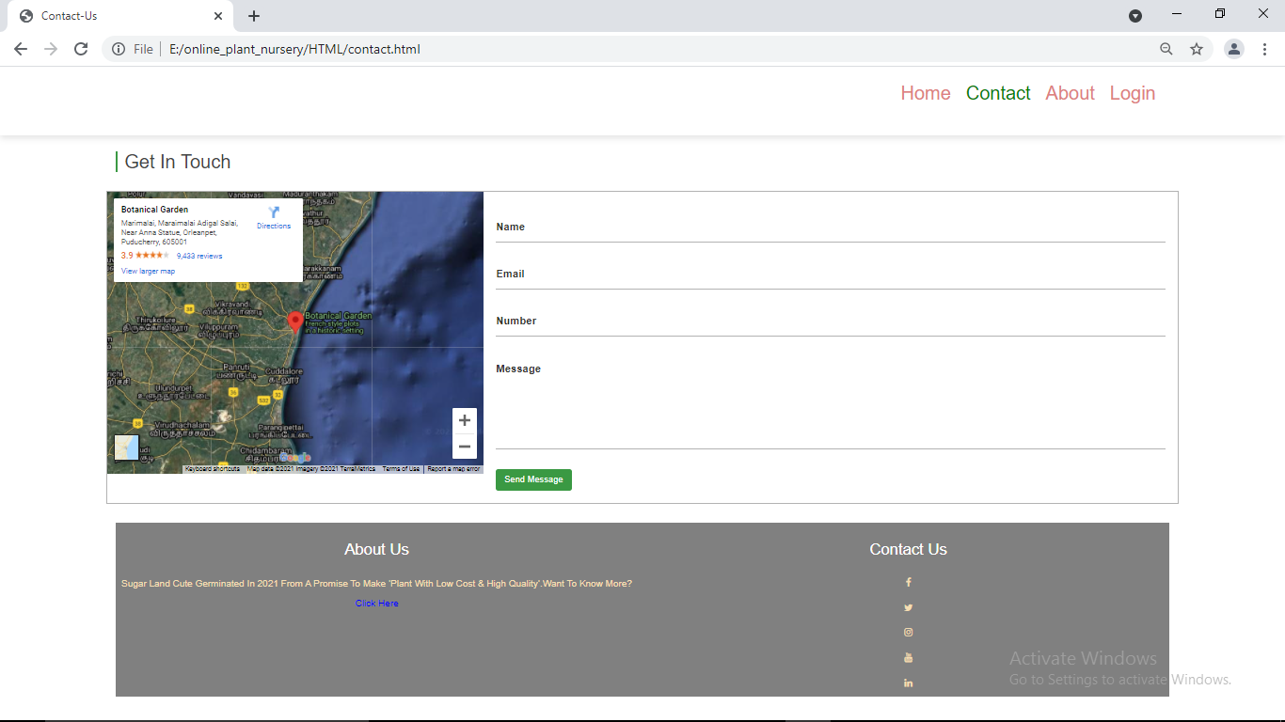

ABOUT PAGE:

The about page has a video that plays only on clicking the video.Play ,zoom in, zoom out,pause and normal option are provided.

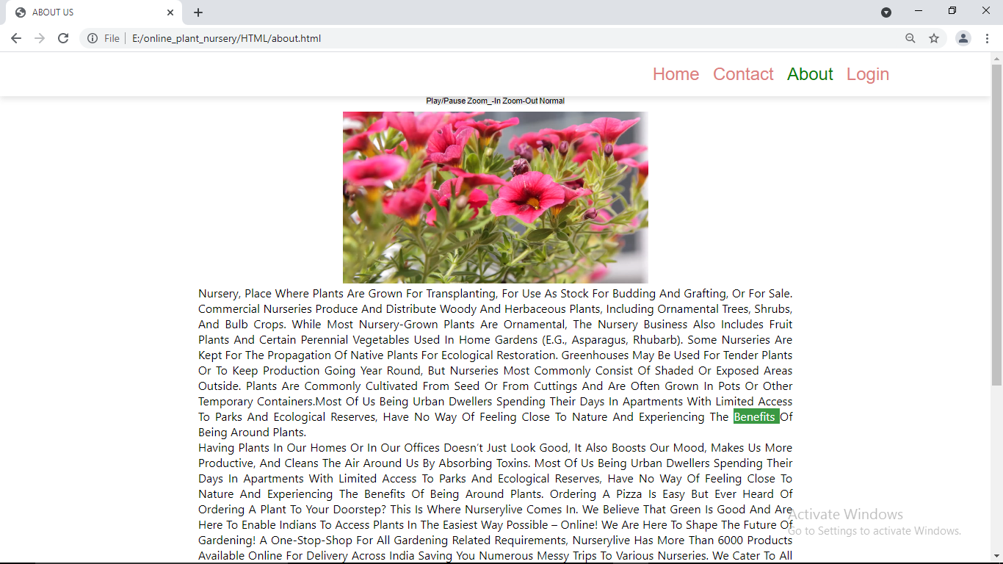

LOGIN PAGE:

Marquee tag is used to slide the image.Only on providing the username as admin and password as user the login is succesfull.

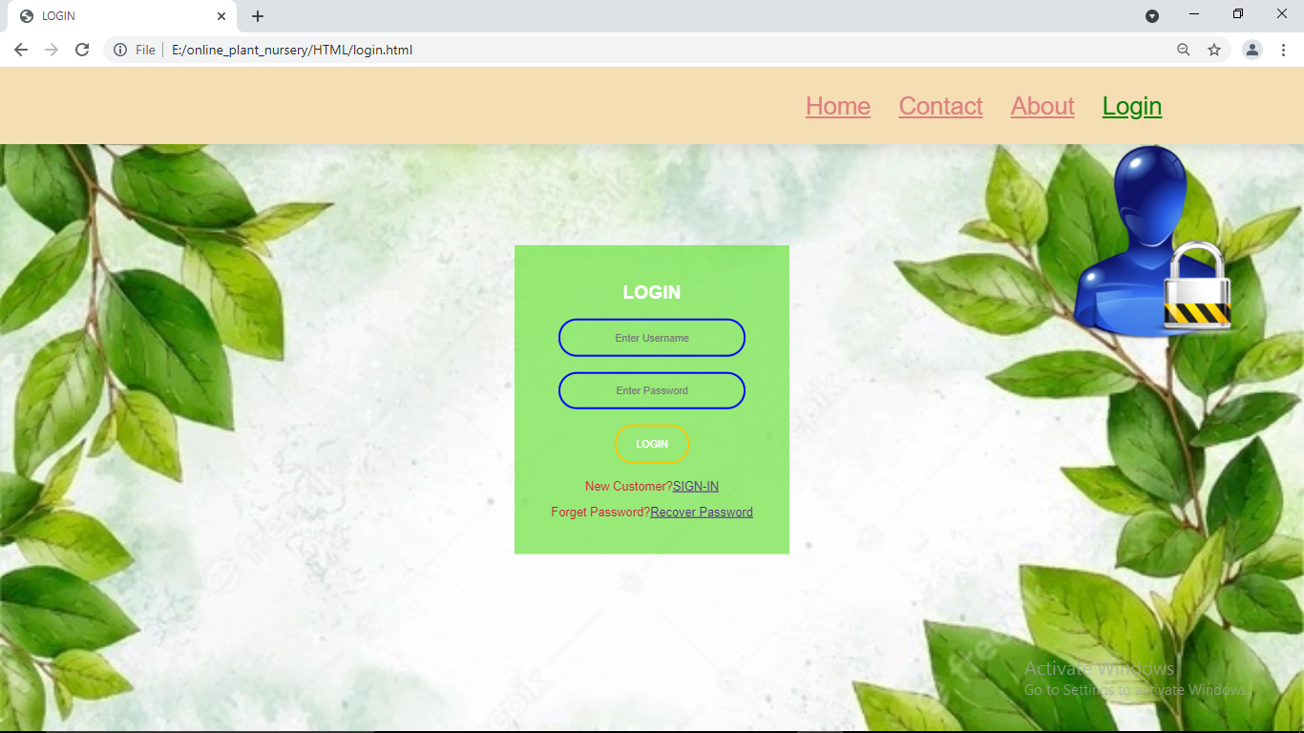

DEAL PAGE:

This special page can been seen only after logging in .table ,lists and styles with images are used

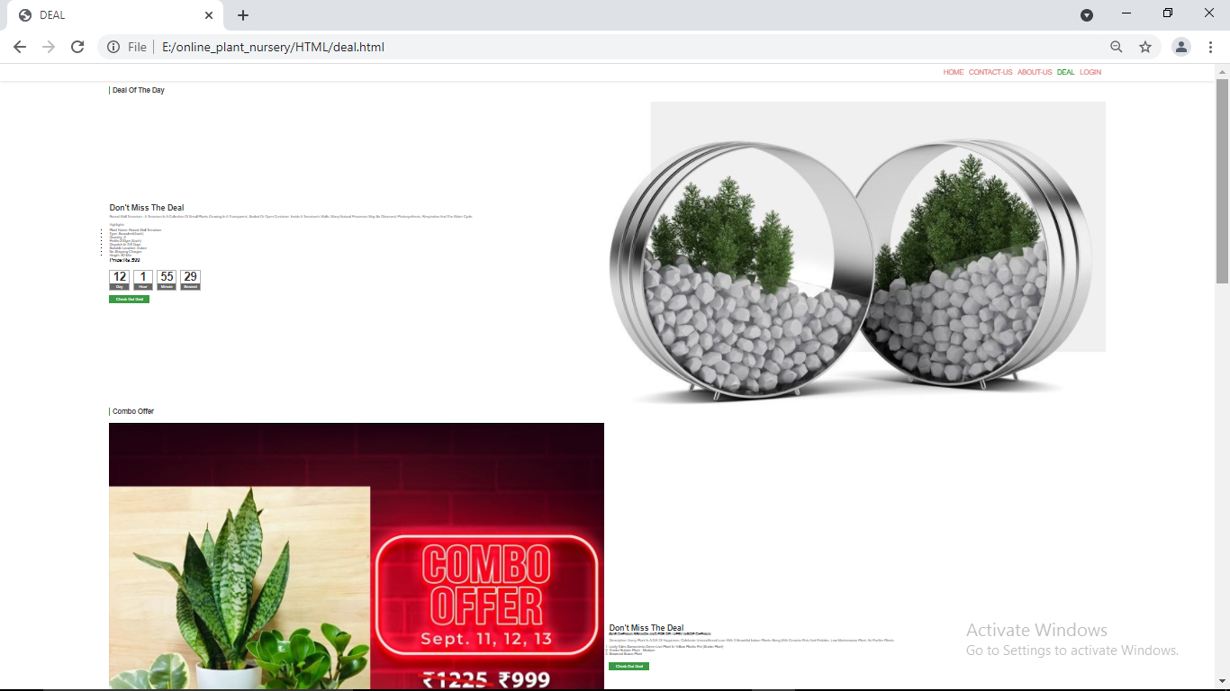

PLANTS:

The plants in the navigation bar of the home plant redirects to this page and seed,bulbs,planters and soil&fertilizer also have their pages which are redirected from home

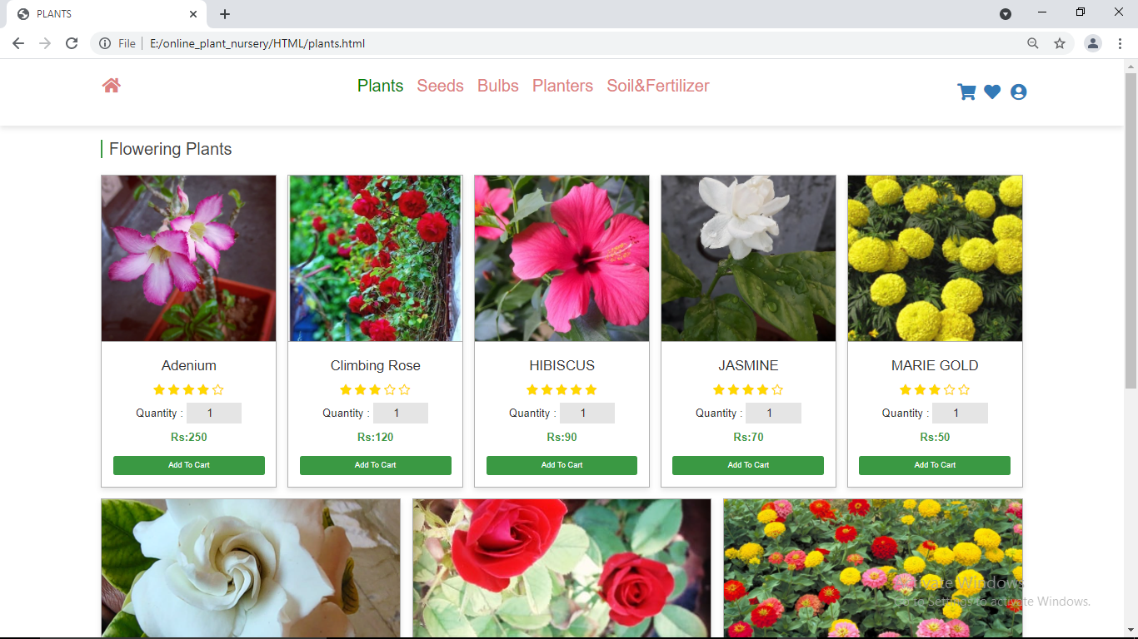

PLANTER:

